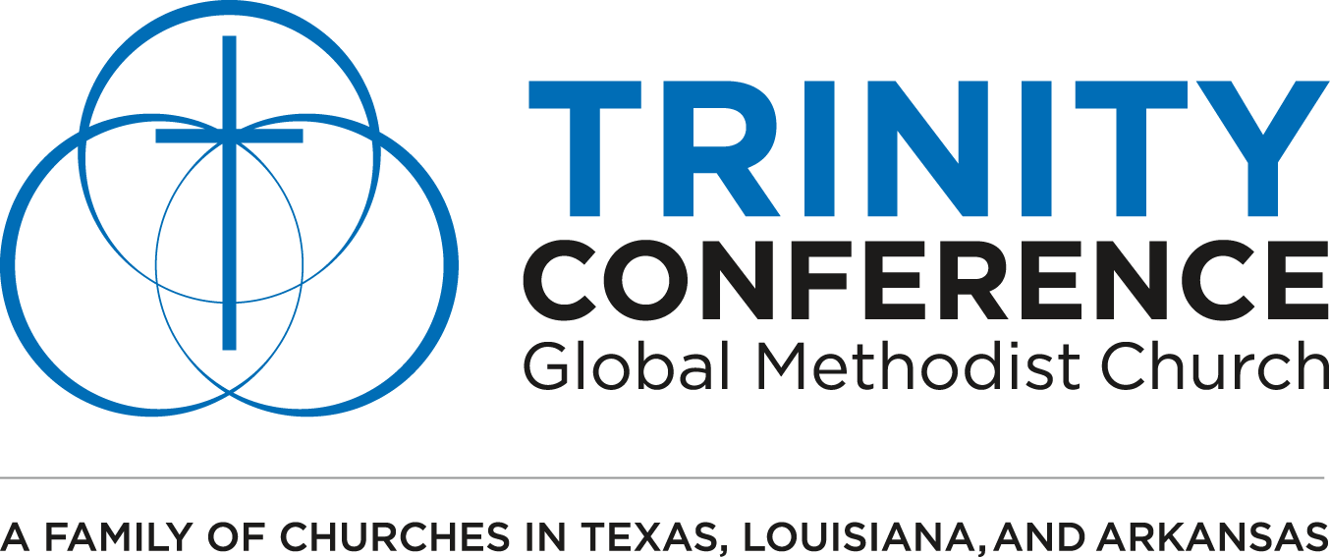
The Class
Meeting Workshop
LEADER GUIDE

Instructions for church leaders:
The coordinating videos are organized into three modules. After each module, you can have tables discuss these questions or discuss them as a group. These questions are designed to launch the conversation so feel free to adapt questions to fit your needs. We suggest that you have a plan of action at the end of the discussion. If you give people an immediate next step then you will have more success.
Module 1: Background for Class Meetings
DISCUSSION QUESTIONS
- Have you ever heard of a class meeting before? If so, what do you know about classes? If not, why do you think these have been so absent from our Methodist churches?
- How might answering a transformational question, like “how is your life in God?” every week with a community of believers have an impact on your faith?
- What do you think the difference is between a transformational group and an informational group?
Module 2: Biblical Discipleship
Discussion Questions
- What does it mean to be a disciple to you?
- This module defined the “the life as Jesus’ disciple as always being devotional, transformational, and missional.” What part of that definition is one that you are most experienced in? Which one do you want to grow in?
- Do you think churches today are training people to be spectators or to be players on the field? What can we do to form more disciples?

Module 3: Class Meetings in your church
Discussion Questions
- Why do you think it could be especially beneficial to meet with a group that has men and women, is intergenerational, and is diverse?
- Consider the difference in an informational question and a transformational question (how are they different? What is the importance of each?)
  - Informational: What does it mean to be a child of God?
  - Transformational: How are you living like a child of God this week?
- What are some obstacles to beginning class meetings in your church? How might you overcome them?

